
FIR/IIR Project #4
Equirriple FIR

Project
You are to design a 31st order lowpass linear phase equiripple FIR sampled at f_{s} = 10k Sa/sec. The filter is to have a passband edge frequency of f_{p} = 1.5k Hz and a stopband edge beginning at f_{a}= 2k Hz. The design specifications are graphically interpreted below on a normalize frequency axis. The allowable passband deviation is ± 0.05 from an ideal value of unity. Your 1st task is to design a 31st order filter, using MATLAB and uniform error weights. Next manipulate the 31st order filter, using the non-uniform error weights to design an FIR that meets the passband gain constraint and maximizes the stopband attenuation.
00.1π0.2π0.3π0.4π0.5π0.6π0.7π0.8π0.9ππ
ϖ
1.0

0.0

0.1
0.0
|H(e^{jϖ})|
Desired magnitude frequency response (pass and stopband)

- Report your findings for uniform error weighted 31st order design:
Display h[k], |H(e^{jϖ})|, |H(e^{jϖ})|_{dB}, ∠H(e^{jϖ}), zero-distribution in the z-plane
Maximum passband error =_________
Maximum stopband attenuation =_________
Group delay (min and max) =_________
Uniform passband and stopband error weights = ______W_{p}=1_____ W_{a}=1____
- Report your findings for the non-uniform error weighted 31st order design that produces an optimal outcome:
Display h[k], |H(e^{jϖ})|, |H(e^{jϖ})|_{dB}, ∠H(e^{jϖ}), zero-distribution in the z-plane
Maximum passband error =_________
Maximum stopband attenuation =_________
Group delay (min and max) =_________
Passband and stopband error weights = __________________________

Report
Report format: 4 page max., with a 1 page cover page.
Due Aug. 5, 2015.
----------------------------------------------
Code snippet

h=firpm(30,[0 .15 .2 .5]*2, [1 1 0 0]);
[H,w]=freqz(h);
figure(1);
plot(w,abs(H))
figure(2);
plot(w,20*log10(abs(H))) % uniform error weight
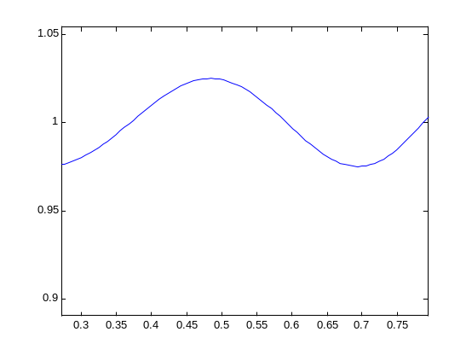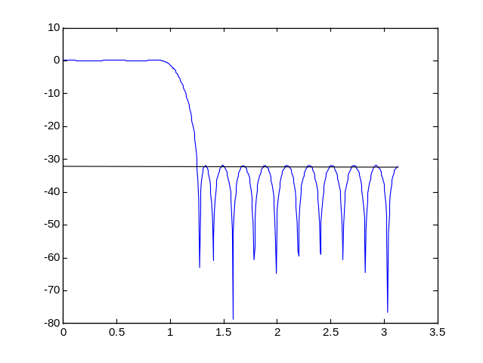
~1.025
Zoom (passband)

